Project 2: Exploratory Data Analysis of Stock Price Time Series
1. Introduction & Dataset Overview
Suggested text (short):
The goal of this project is to explore daily stock price data with the aim of understanding its chronological order, variability, and how suitable it is for time-series modeling. The dataset contains daily observations of opening and closing prices over a fixed period.
And exploratory data analysis was conducted to examine trends, stationarity, and short-term behavior of the dataset, including the changes that can be made to it to make it suitable for forecasting.
2. Dataset Structure and Variables
A .info() Python function , along with .head() were used:
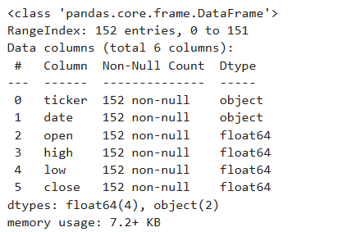
Figure 1:These shot summarizes the structure of the dataset, including variable types and the number of observations (rows). The dataset consists of a time variable (date) and numerical price-related variables (closing and opening), and no missing-values. But some are in a form of object data types which is something to look into before going further.

3. Time Indexing and Ordering: The Dataset indexed by date
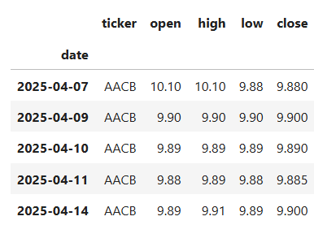
Figure 2:As seen initially, date was taken as an object but before preoceeding furtherthe dataset was sorted with time or date as the index. The product of this posted above using te.head() function. Having time in this form allows visualiztions through matplotlib.pyplot, models to compute lags and align obsrvations as it will be seen througout this report, or even having the ‘before’ and ‘after’ notions in the dataset analysis.

- Distribution of Closing Prices
One of the questions asked here is related to te corrrelation to at least a pair of columns, selecteed to answer this being the closing price and the date index.
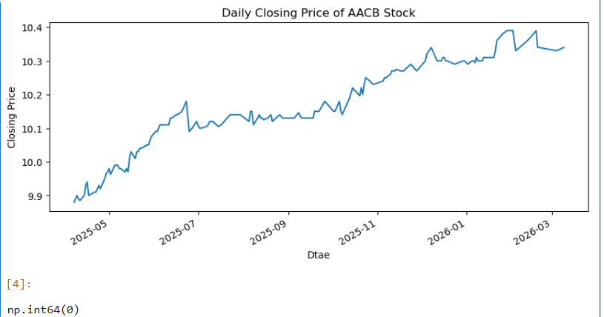
Figure 3:The distribution of closing prices is concentrated within a narrow range, reflecting relatively low price volatility over the observed period. However, the presence of a trend suggests that distributional summaries alone are insufficient for time-series modeling.
- Transforming Prices to Daily Returns: there was a visible trend betwwen prices and the time index, which is not good for models such ARIMA, which assume constant mean and variance while a trend means otherwise.
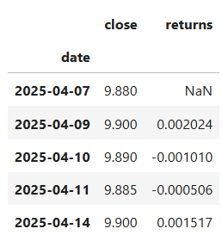
Figure 4:Daily returns were computed as percentage changes in closing prices to remove the long-term trend observed in the price series. The resulting series fluctuates around zero, suggesting improved stationarity relative to the original price data.

- Distribution of Daily Returns: if raw prices show a trend, will using daily returns fare better and remove it
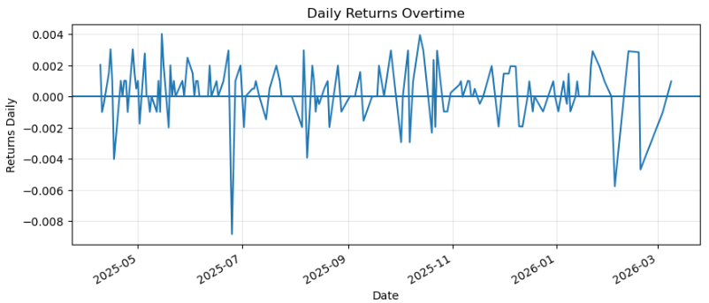
Figure 5: The distribution of daily returns is centered near zero with a high concentration of small changes and a few extremities. This behavior of capturing outliers is typical of stocks. BUt all in all it shows a somewhat constant mean, and no trend line, which makes it better for analysis.

- Assessment of Stationarity
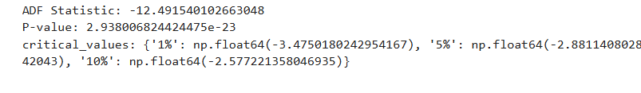
Figure 6:An Augmented Dickey–Fuller (ADF) test was applied to the return series to assess stationarity. The extremely negative test statistic and near-zero p-value indicates a strong rejection of the unit-root hypothesis, confirming that the return series is stationary. Which goes in ine with the assessment of the plot at 6.
8. Time-Based Train–Test Split
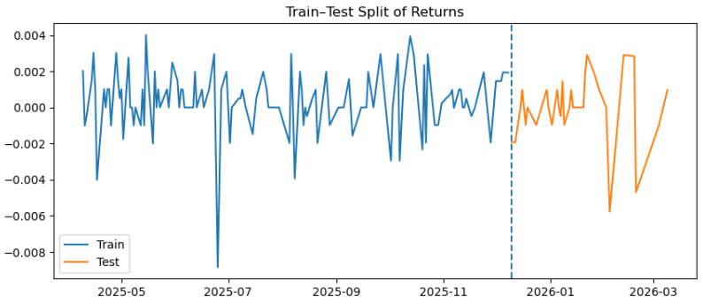
Figure 7:The return series was split into training and testing sets (approximately 80% and 20% in favor of training data(120 and 31)) using a time-based split to preserve temporal ordering. This approach avoids data leakage and mirrors real-world forecasting conditions in the sense that training of amodel is done on already known data and used to forecast on unknown.

9. Baseline Time-Series Modeling (Without ACF/PACF, does this make any difference to thepredictions or performance of the model?)
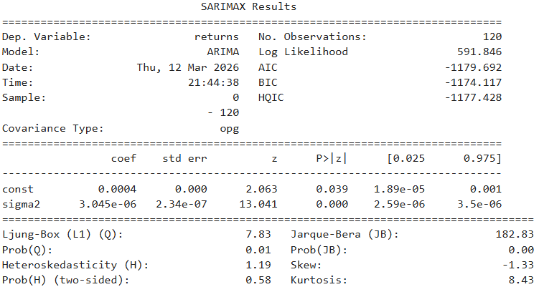
Figure 8:A baseline ARIMA(0, 0, 0) model was fitted without prior ACF/PACF guidance to serve as a reference point. While the model captures basic structure, residual diagnostics suggest remaining autocorrelation, indicating underfitting.

- ACF/PACF PLots To Determine A model
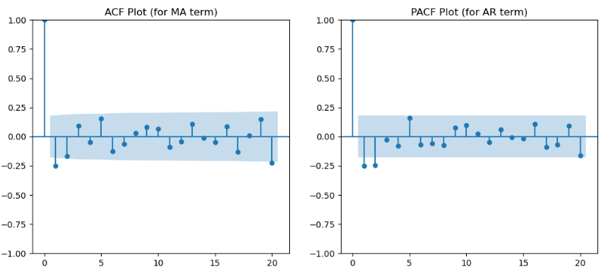
Figure 9:Intitialy a model was chosen witout using ACF or PACF to see the suitable version of ARIMA, but lloking at te above plots and every lag being eithin the blue area and slight pokes instaed of using (0, 0, 0) for MA 2 was used and 1 for AR, giving ARIMA(2, 0, 1). Wich was then used to see which version goes wit such a set.
11.ARIMA(2,0,1) diagnostics or forecast vs actual
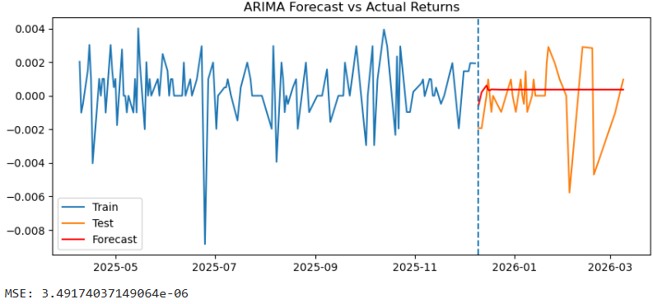
Figure 10:An ARIMA(2,0,1) model selected using ACF and PACF analysis demonstrates improved performance, with lower AIC values and residuals that resemble white noise. This suggests that incorporating correlation structure improves model adequacy.

12. Model Comparison
Visualization 11: Model comparison table (AIC & diagnostics)
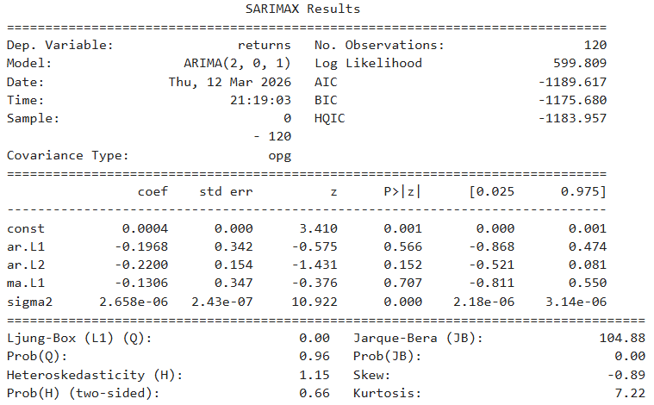
Figure 11:Comparing multiple ARIMA specifications shows that the ACF/PACF-informed model achieves the best balance between goodness-of-fit and residual behavior. Over-differenced or overly simple models perform worse according to AIC and diagnostic tests.
12. Key Insights and Lessons Learned
This exploratory analysis shows that while stock prices exhibit clear non-stationary trends, daily returns are stationary and more suitable for time-series modeling. Simple baseline models (0, 0, 0) provide useful reference points, but incorporating correlation structure via ACF/PACF improves statistical adequacy, as seen in selecting te (2, 0, 1) which was a great improvement. While the (0,0,0) configuration failed to capture the temporal dependencies in the data, the (2,0,1) model successfully cleared the Ljung-Box diagnostic with a p-value of 0.96. However, the persistent high kurtosis and Jarque-Bera failure across both models highlight the presence of "fat tails" and volatility clustering typical of financial returns, though another model is recommendable to handle te variance.
Some analysis were also done like to check for the timely order of the data and see if its ordered in a monotonic way because it was taken at the same intervals, which are also greatly imported to modelling of such a set.

